Amanda Giarrizzo
Geogebra Lesson: Area of a parallelogram using rectangles
Website used: http://www.youtube.com/watch?v=qkqlZSvbmxA (Area of a Parallelogram, Tina Helms)
Grade: 6th

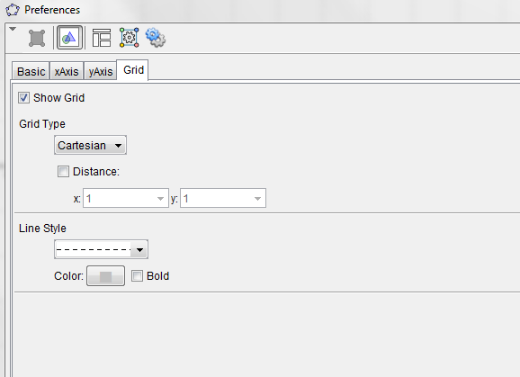
Step 1: Turn the Grid on
- Click Settings (top right corner)
- Click the Graphics tab
- Click the Grid Tab
- Check off the Show Grid box
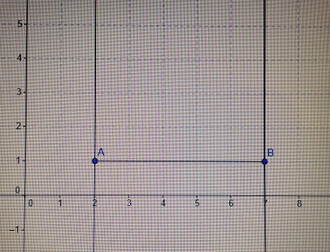
Step 2: Create a Rectangle
- Click the line tab on the tool bar and select Segment (2nd one down)
  - Plot your segment points at (2,1) and (7,1)
- Click the perpendicular line tab on the tool bar and click on line a (segment AB) and point A
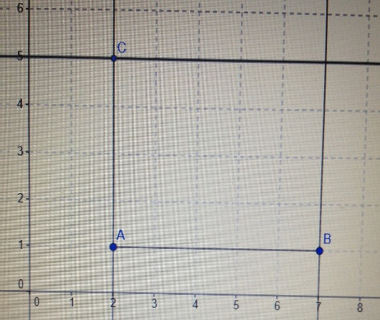
  - Then click on B and line a (segment AB)
- Click the point tab on the tool bar and create the point C at (2,5)
- Then select the perpendicular line tab on the tool bar and click on line b (AC) and point C
- Click the point tab and select Intersect (4th one down)
  - Click on the two lines g and h
- Click the Segment tab
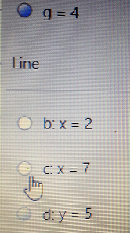
- Connect AC, CD, and BD to make segments
- On the algebra tool bar, under the line tab unclick the circles for b,c, and d (the line x=5 will still be present)
- Click on the line segment AB
  - Right click and press rename
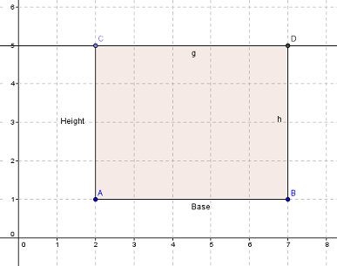
  - Rename the segment, Base
  - Hit enter
- Click on the line segment AC
  - Right click and press rename
  - Rename the segment, Height
  - Hit enter
- Click the polygon button on the tool bar
  - Connect all the points ABDCA
- Area formula for a rectangle: ______________
- Area of rectangle ABDC: _________________
- Click on the Angle table on the tool bar
  - Select the Area tab (4th one down)
- Is your area equal to the one on the screen? _________________

Step 3: Create a Parallelogram using the Rectangle ABDC
- Click the Point tab on the tool bar
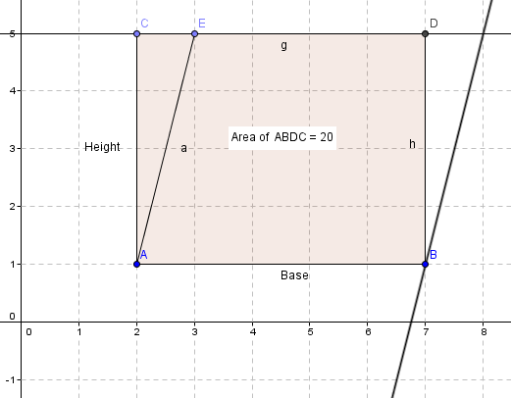
  - Plot the point (3,5) on line CD
- Click the Segment tab on the tool bar
  - Connect points A and E
- Click the Perpendicular line tab on the tool bar
  - Select Parallel line tab (2nd from top)
  - Click line segment AE and point B
- Click the Point tab on the tool bar
  - Select Intersect tab (4th one down)
  - Click on line e & j
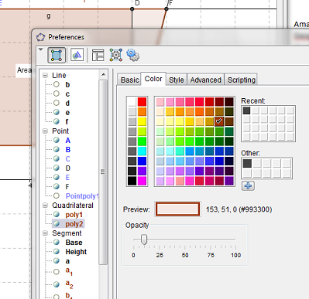
- Click the Polygon tab on the tool bar
  - Connect all the points ABFEA
- Click on the Point tab on the tool bar
  - Put your cursor in the parallelogram (anywhere it is not intersecting with rectangle ABDC)
  - Right click
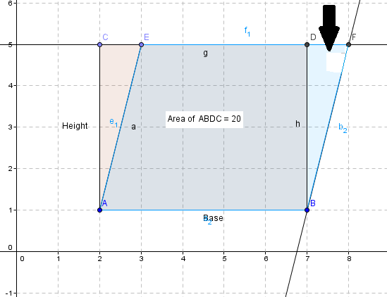
  - Click object properties
  - Select the Color Tab
  - Change the Color to anything you would like
  - Hit Enter
- Click on the Area tab on the tool bar
  - Click on a spot in the parallelogram where it is not intersecting with rectangle ABDC

- What is the area of parallelogram ABFE? ___________
- Is it the same area as the square ABDC? ___________
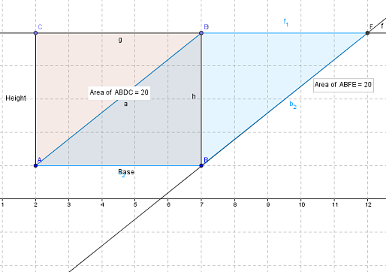
Step 4: Use the point on the parallelogram to measure area
- Click the Point tab on the tool bar
  - Click on Point E
  - Drag it along the line e (CD)
- Does the area change when you move the point? __________________
- What two measures do you think the area depends on? _____________________________________
- What is the area formula for a parallelogram? _____________________________________
- How do the area formulas for a rectangle and parallelogram relate?
_____________________________________________________
Practice problems:
- What is the area of a parallelogram ABCD with points A (2,3) B (5.3) C (2, 7) D (5, 7)? How did you find this answer?
_____________________________________________________
- What is the area of a parallelogram ABCD with points A (6, 11) B (9, 11) C (6, 20) D (8, 20)? How did you find this answer?
_____________________________________________________
Challenge Problems:
- If I had a rectangle ABCD with points A (1,3) B (6,3) C (1,8) D (6, 8), what would the area of a parallelogram, that has the same base and height of the rectangle, be? How do you know this?
_____________________________________________________
- If I had a rectangle ABCD with points A (6,8) B (10,8) C (6,12) D (8, 12), what would the area of a parallelogram, that has the same base and height of the rectangle, be? How do you know this?

